6.104: From 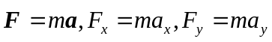 and 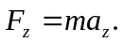 The generalization of Eq. (6.11) is then
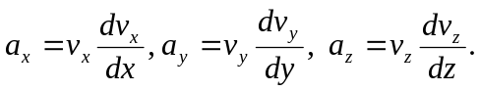
The total work is then
